LAB EXPERIMENTS AND EXECUTED OUTPUT

NAME | GEETIKA T
REG NO | 192511469
COURSE | ARTIFICIAL INTELLIGENCE
COURSE CODE | CSA1701

EXPERIMENT-1:Write the python program to solve 8 Puzzle problem

AIM
To write a Python program to solve the 8-Puzzle problem using the A* search algorithm with Manhattan Distance as the heuristic function.

ALGORITHM
1. Start the program.
2. Define the initial state and the goal state of the 8-Puzzle.
3. Represent the blank space using 0.
4. Define the Manhattan Distance heuristic to calculate the distance
of each tile from its goal position.
5. Calculate the cost using f(n) = g(n) + h(n), where g(n) is the
number of moves made and h(n) is the Manhattan Distance.
6. Find the position of the blank space (0).
7. Generate all possible moves of the blank space: Up, Down, Left
and Right.
8. Create new puzzle states for each valid move.
9. Select the state having the lowest f(n) value.
10. Mark the selected state as visited.
11. Repeat steps 6 to 10 until the goal state is reached.
12. Display the sequence of puzzle states and the number of moves.
13. Stop the program.

PROGRAM:

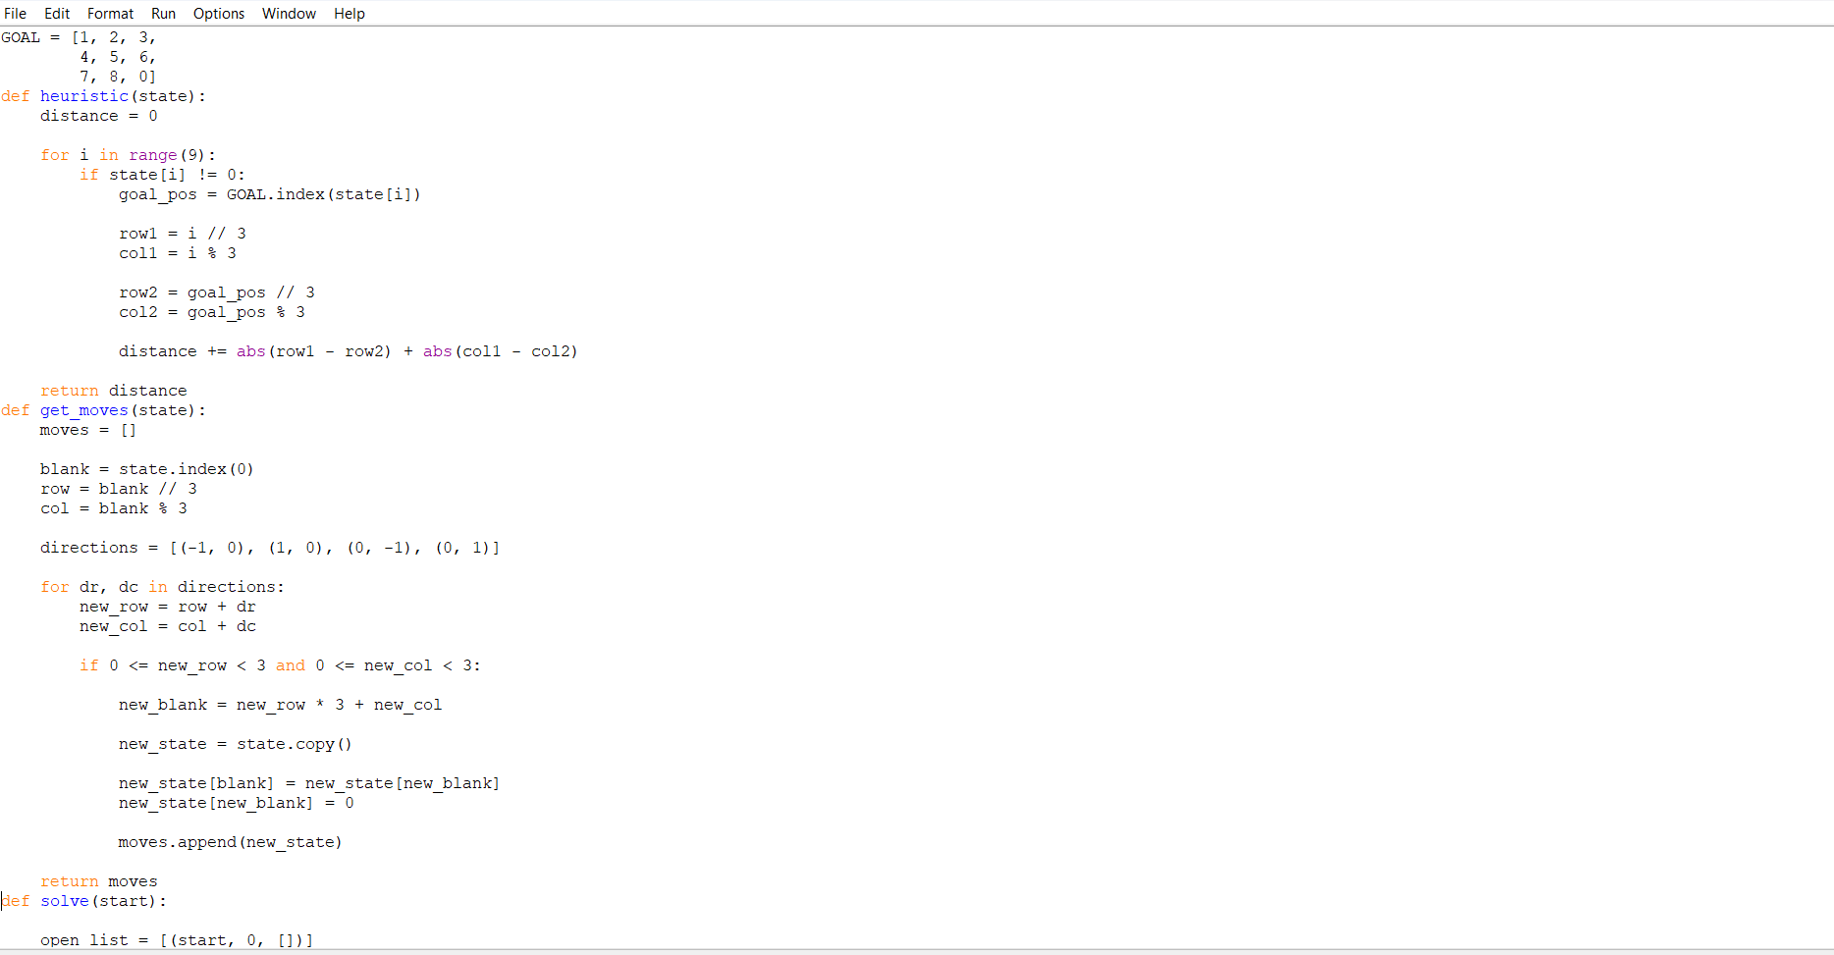
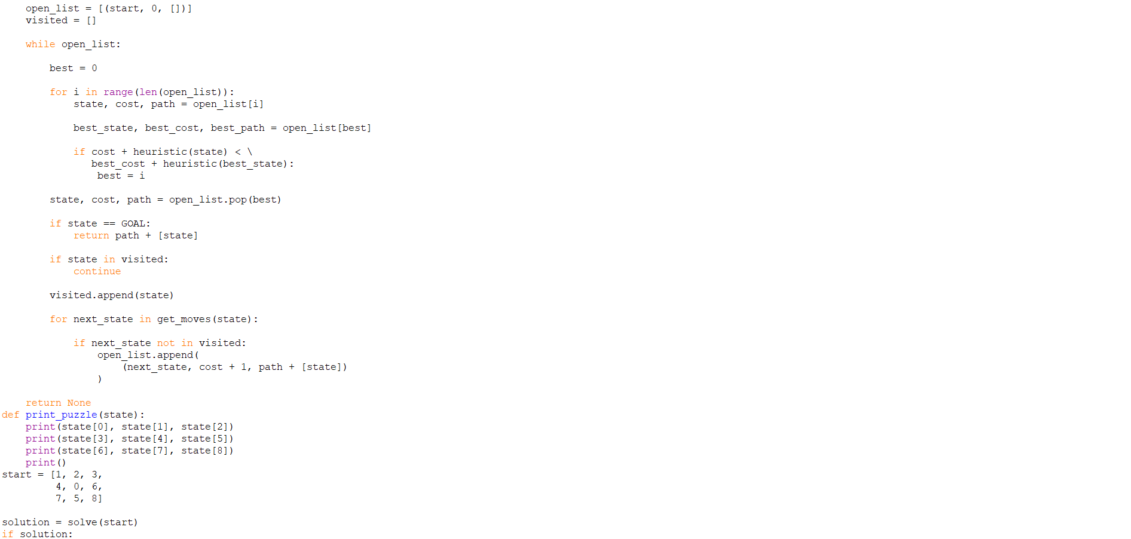

SAMPLE OUTPUT(SCREENSHOT):
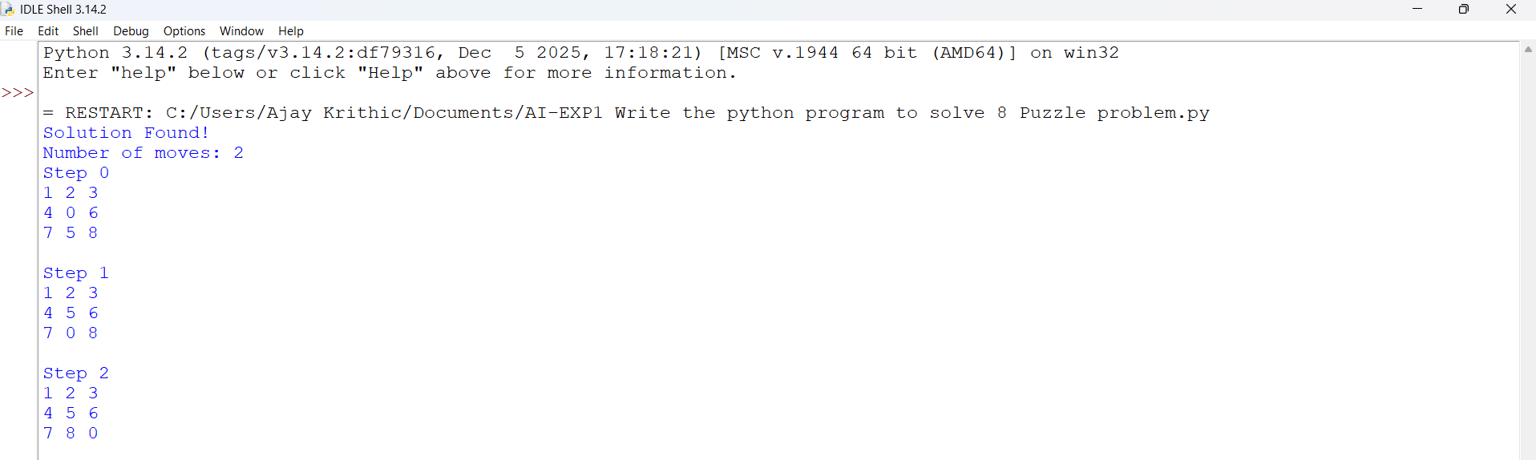

RESULT
The 8-Puzzle problem was successfully solved using the A* search algorithm with Manhattan Distance as the heuristic. The program finds and displays the optimal sequence of moves from the initial state to the goal state.

EXPERIMENT 2:Write the python program to solve 8-Queen problem

AIM:

To write a Python program to solve the 8-Queen problem using the Backtracking technique.

ALGORITHM:
1. Start the program.
2. Initialize an 8×8 chessboard.
3. Place a queen in the first row.
4. Check whether the current position is safe.
5. A position is safe if no other queen is present in the same column or diagonal.
6. If the position is safe, place the queen and move to the next row.
7. If no safe position is found, backtrack to the previous row and change the queen's position.
8. Repeat the process until all 8 queens are placed.
9. Display the chessboard with the positions of all 8 queens.
10. Stop the program.

PROGRAM:
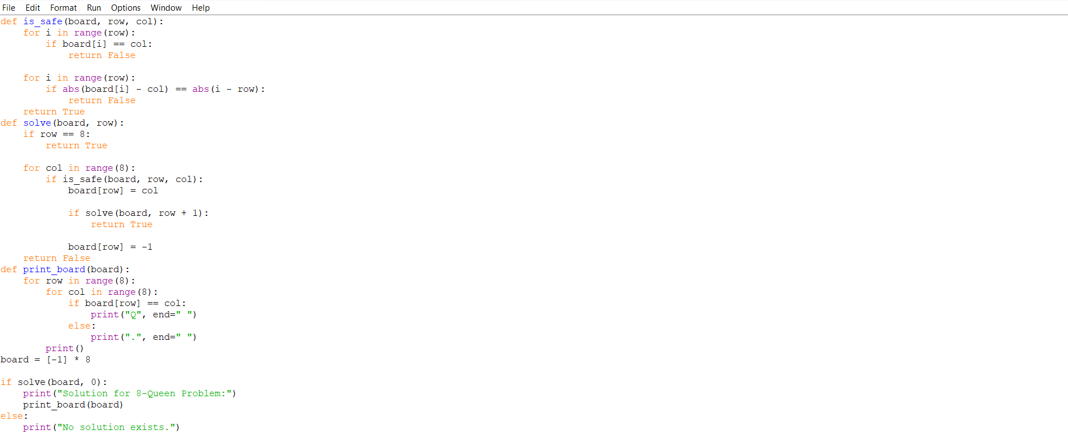

SAMPLE OUTPUT:

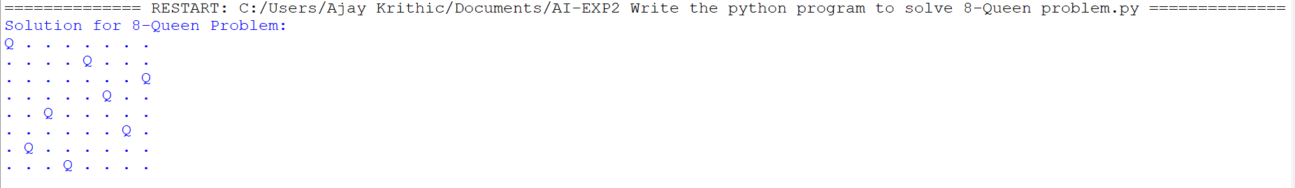

RESULT:
The 8-Queen problem was successfully solved using the Backtracking technique, and a valid arrangement of 8 queens was obtained such that no two queens attacked each other.

EXPERIMENT 3:Write the python program for Water Jug Problem

AIM:
To write a Python program to solve the Water Jug Problem using the Breadth First Search (BFS) technique.

ALGORITHM:
1. Start the program.
2. Define the capacities of the two jugs and the required target amount.
3. Represent the state as the amount of water present in both jugs.
4. Start with the initial state (0, 0).
5. Generate all possible states by performing the following operations:
a. Fill the first jug.
b. Fill the second jug.
c. Empty the first jug.
d. Empty the second jug.
e. Pour water from the first jug into the second jug.
f. Pour water from the second jug into the first jug.
6. Store each visited state to avoid repetition.
7. Use BFS to explore the states level by level.
8. Continue until a state containing the target amount is reached.
9. Display the sequence of states leading to the solution.
10. Stop the program.

PROGRAM:
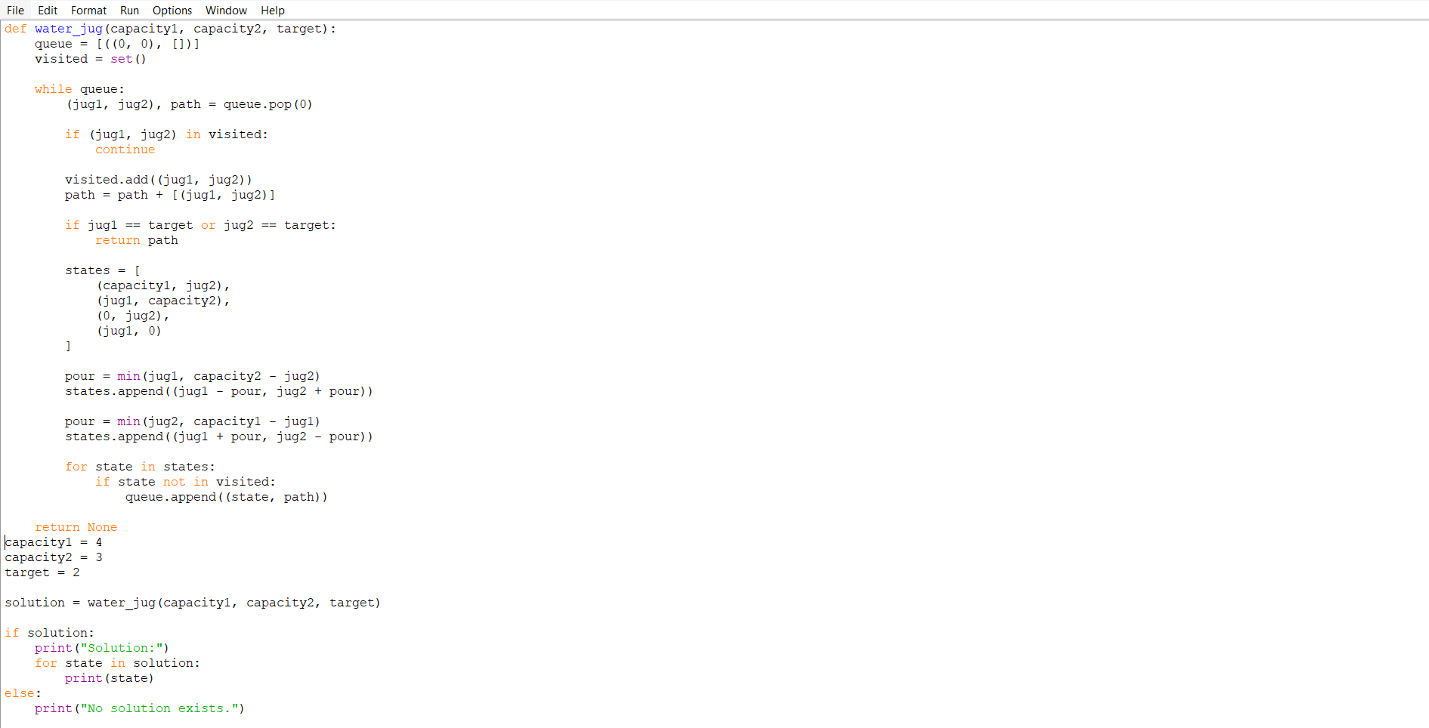

EXECUTED OUTPUT:
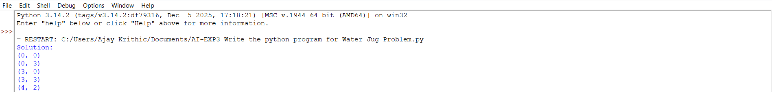

RESULT:

The Water Jug Problem was successfully solved using the Breadth First Search (BFS) technique, and the sequence of states required to obtain the target amount of water was displayed.

EXPERIMENT-4 Write the python program for Cript-Arithmetic problem

AIM
To write a Python program to solve a Crypt-Arithmetic problem using the Backtracking technique.

ALGORITHM
1. Start the program.
2. Define the words involved in the crypt-arithmetic problem.
3. Identify all unique letters present in the words.
4. Assign a unique digit from 0 to 9 to each letter.
5. Ensure that the first letter of each word is not assigned 0.
6. Substitute the assigned digits for the corresponding letters.
7. Check whether the arithmetic equation is satisfied.
8. If the equation is satisfied, display the letter-to-digit mapping and the result.
9. If the equation is not satisfied, backtrack and try another digit assignment.
10. Repeat the process until a valid solution is found.
11. Stop the program.

PROGRAM:
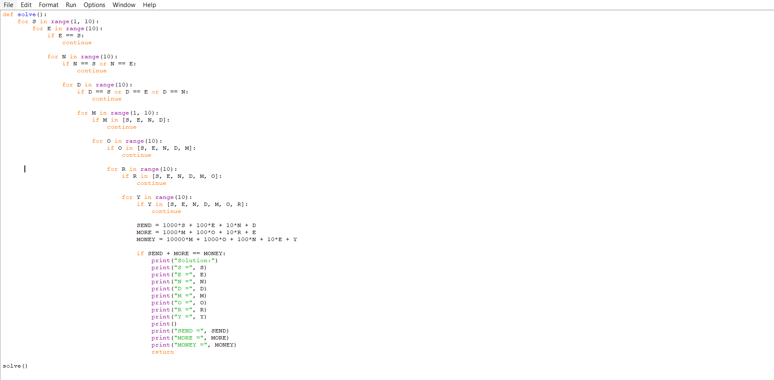

EXECUTED OUTPUT:
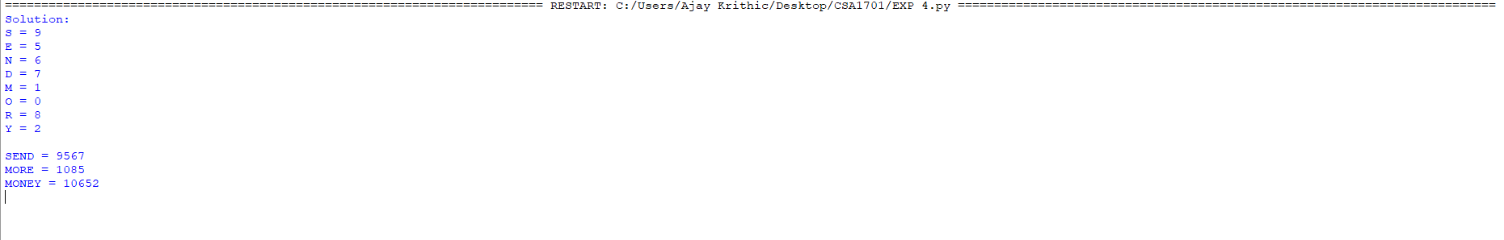

RESULT:
The Crypt-Arithmetic problem was successfully solved using the Backtracking technique, and a valid digit assignment for each letter was obtained satisfying the given arithmetic equation.

EXPERIMENT 5:Write the python program for Missionaries Cannibal problem

AIM
To write a Python program to solve the Missionaries and Cannibals problem using the Breadth First Search (BFS) technique.

ALGORITHM
1. Start the program.
2. Represent the state as (M, C, B), where M is the number of missionaries,
C is the number of cannibals on the left side, and B represents the
position of the boat.
3. Initialize the starting state as (3, 3, 1).
4. Define the goal state as (0, 0, 0).
5. Generate all possible boat movements by carrying one or two people.
6. Check whether the new state is valid.
7. A state is valid if missionaries are not outnumbered by cannibals
on either side, unless there are no missionaries on that side.
8. Store visited states to avoid repeating states.
9. Use BFS to explore the valid states level by level.
10. Continue until the goal state is reached.
11. Display the sequence of states from the initial state to the goal state.
12. Stop the program.

PROGRAM:
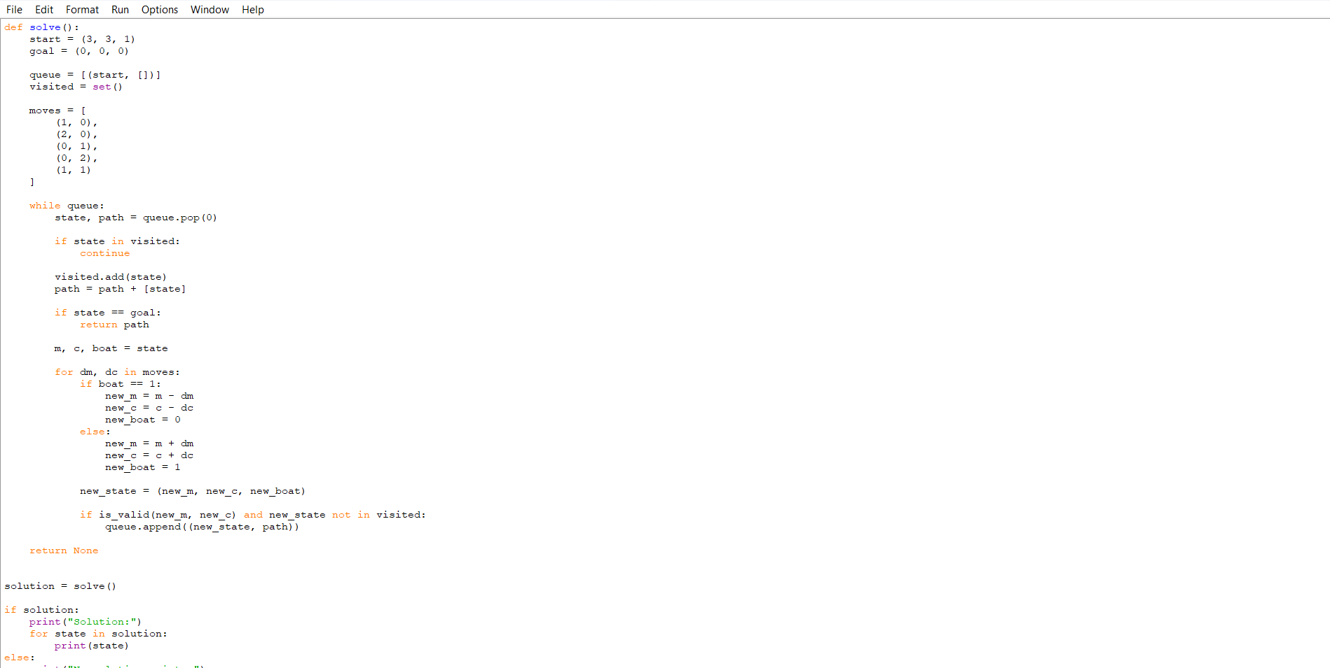

EXECUTED OUTPUT:
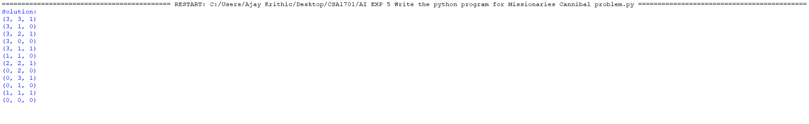
RESULT
The Missionaries and Cannibals problem was successfully solved using the Breadth First Search (BFS) technique, and a valid sequence of states for safely transporting all missionaries and cannibals across the river was obtained.

